**HOTEL RENTAL MANAGEMENT**

**Phase 02**

**Screen Shots for the project**

**WELCOME SCREEN:**

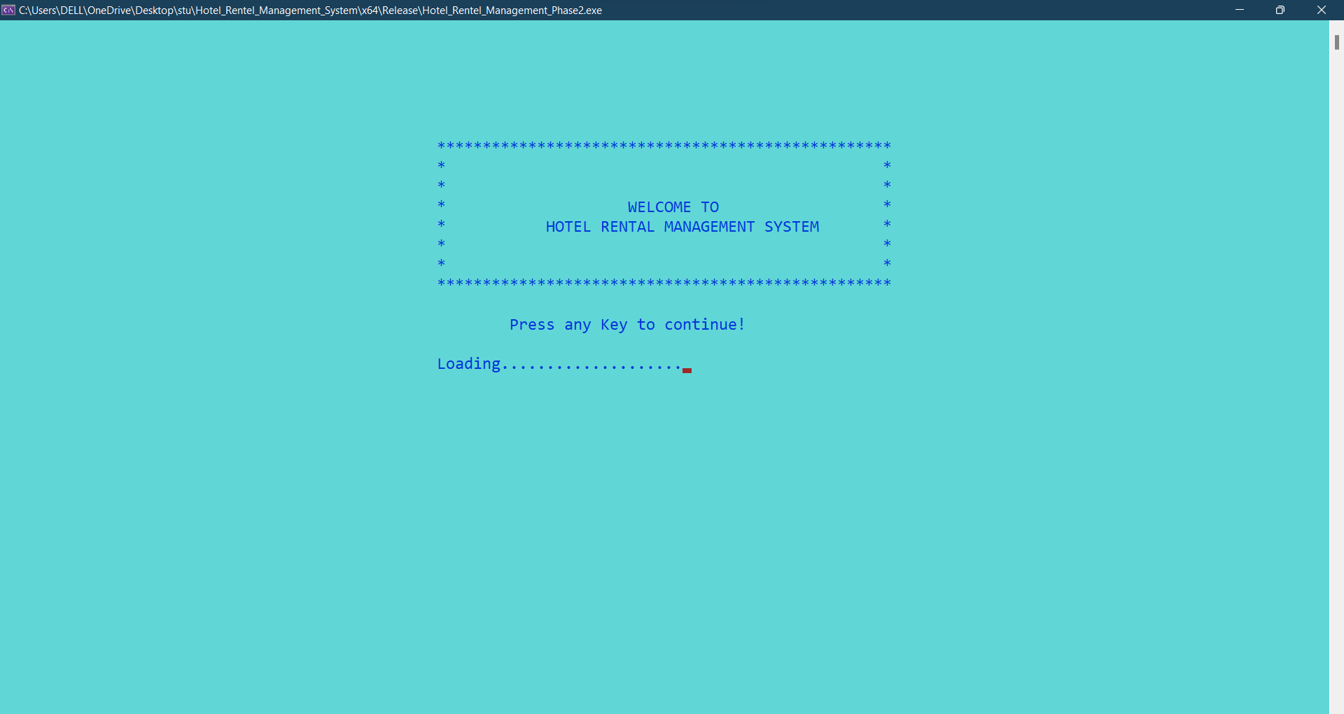

**LOGIN MENU SCREEN:**

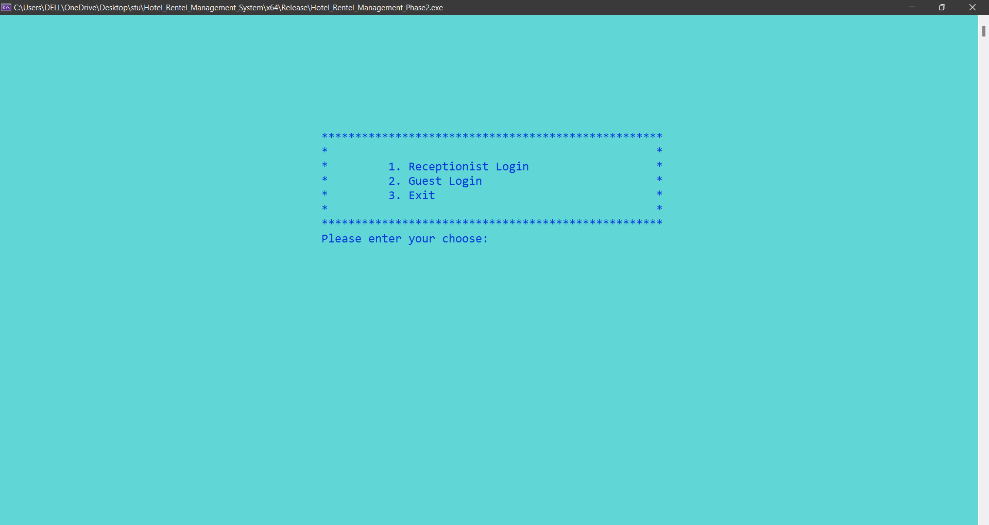

**Receptionist LOGIN MENU SCREEN:**

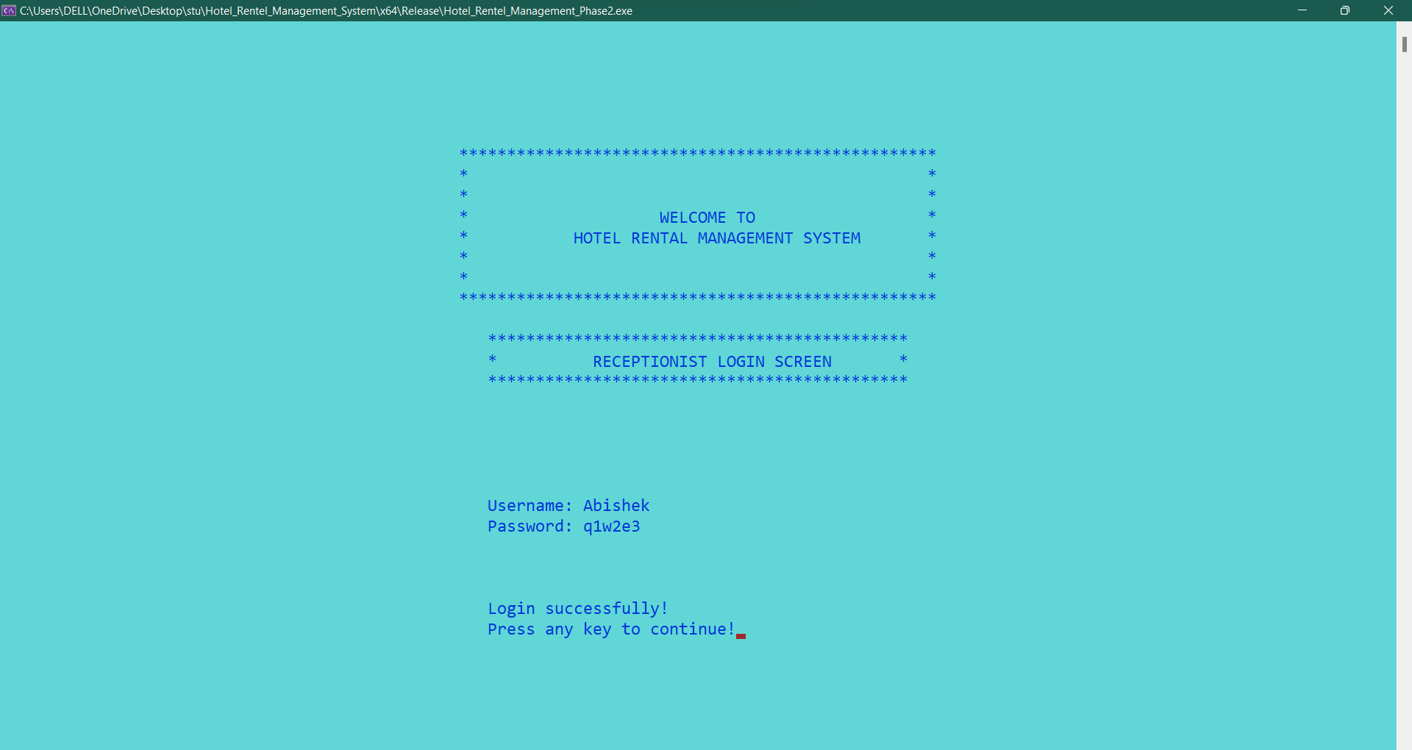

Login details in Login_credentials Table:

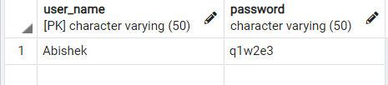

**Guest LOGIN MENU SCREEN:**

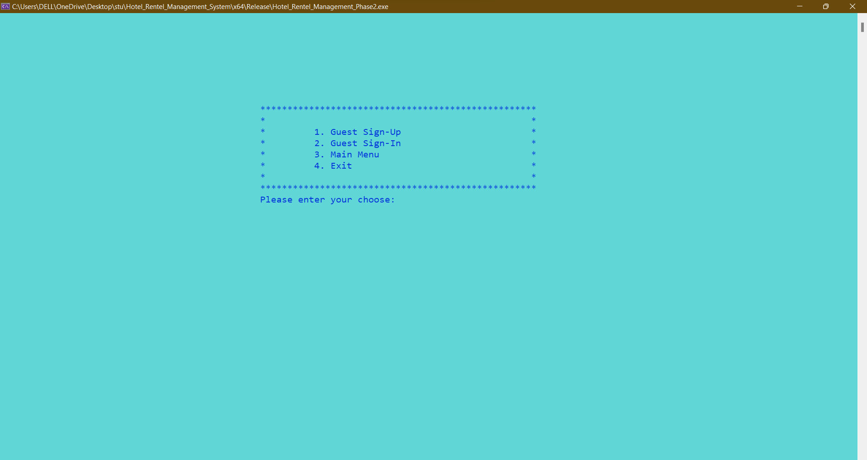

**Receptionist Main Screen**

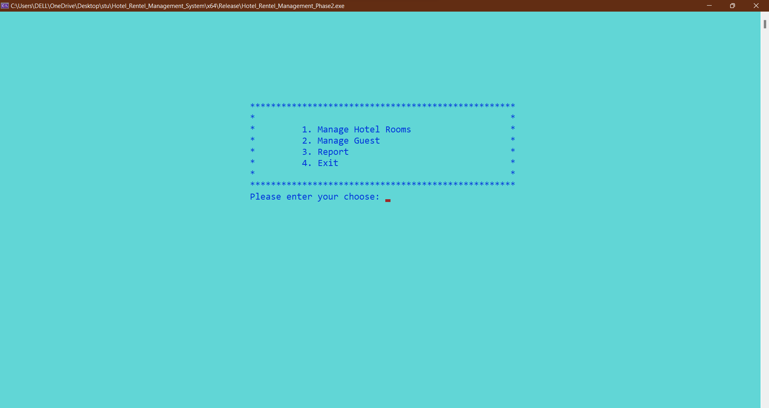

**On Pressing 1. Manage Hotel Rooms Information**

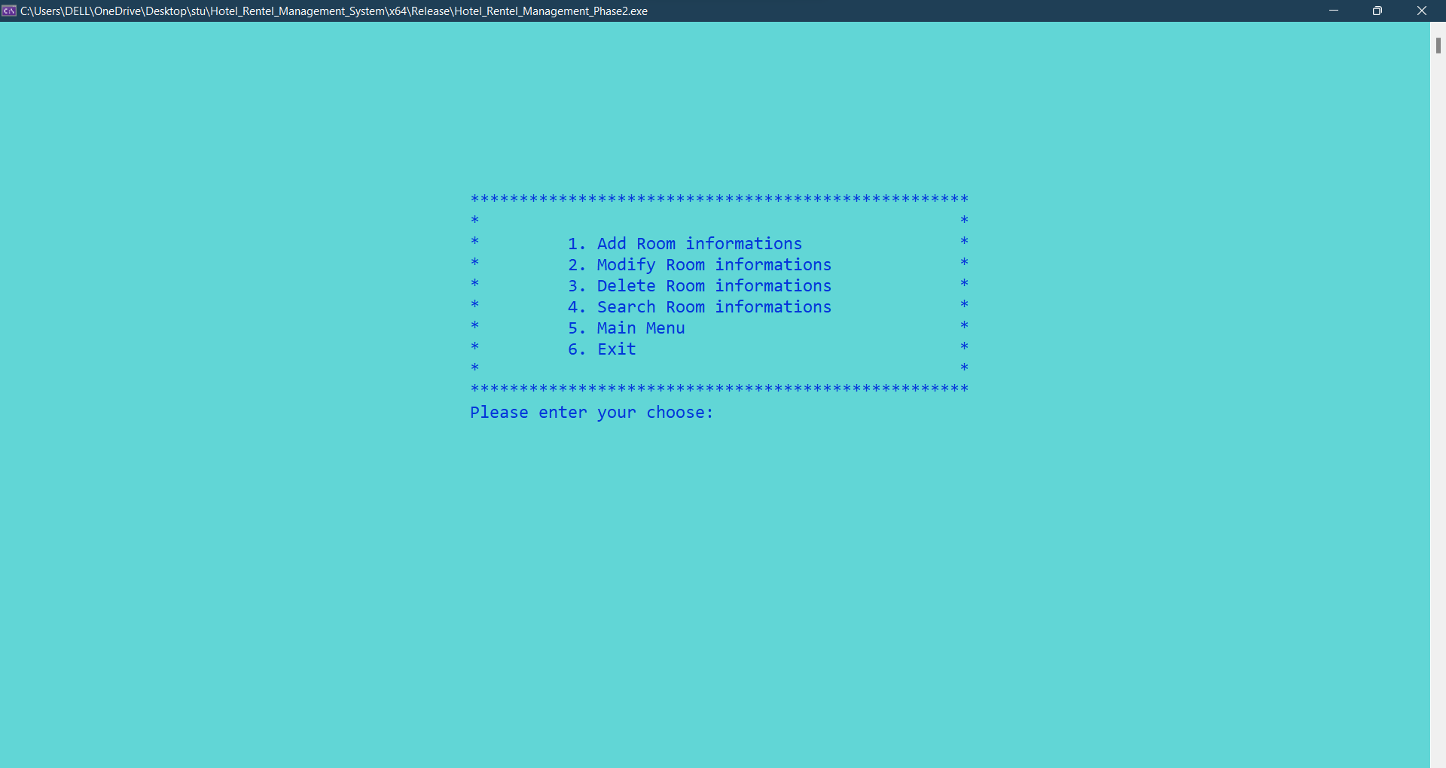

**CRUD OPERATIONS IN ROOM’S MANAGEMENT**

**Inserting** Room Information into Database:

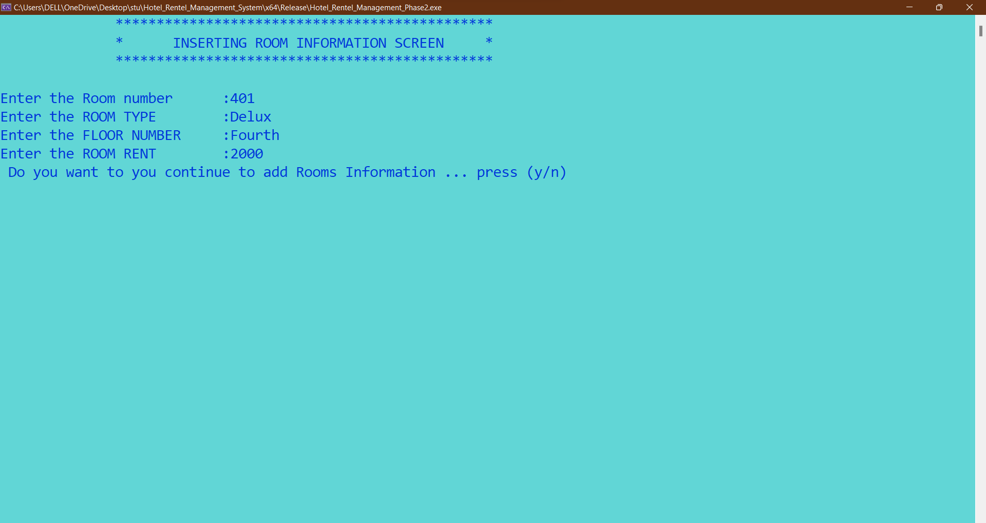

**Hotel Rooms Information in table after inserting:**

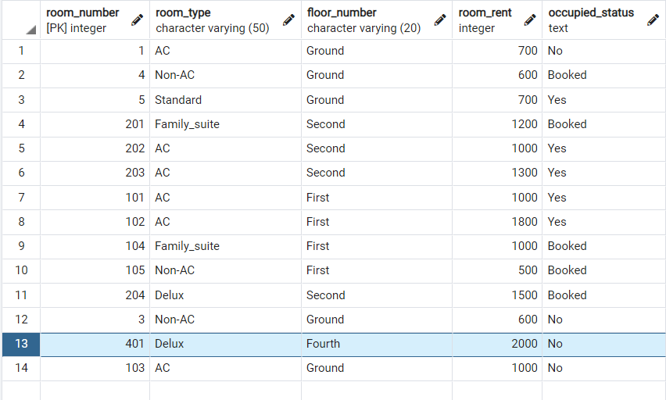

**Updating Room Information** into Hotel_room_info Table:

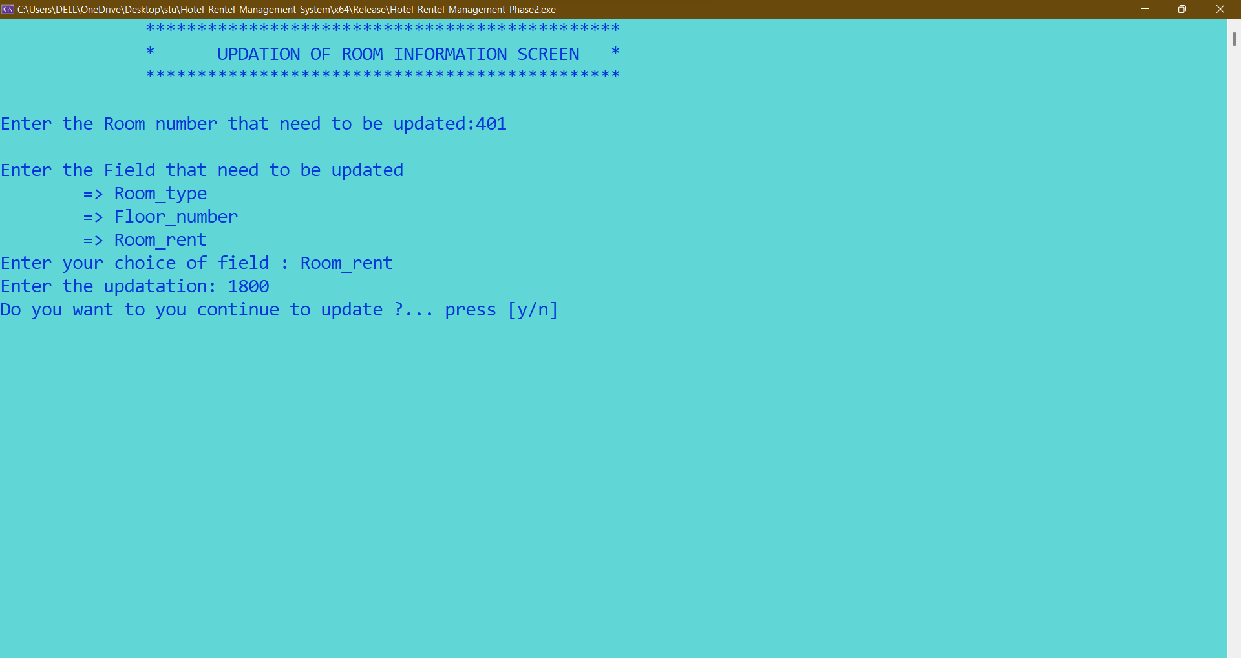

**Hotel Rooms Information in table after Updating:**



**Deleting Rooms Information:**

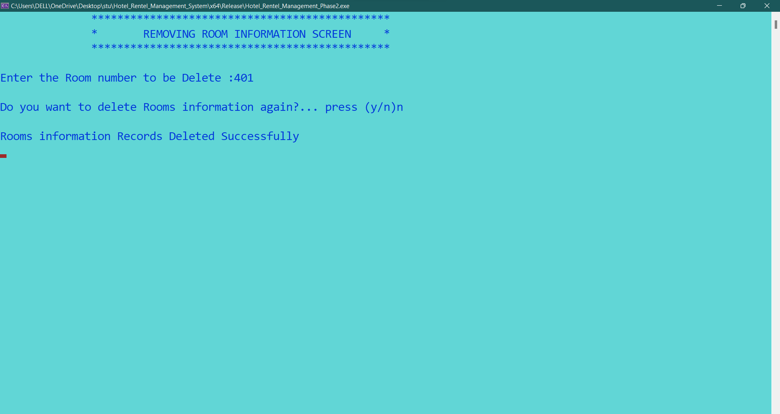

**Hotel Rooms Information in table after deleting Room .401:**

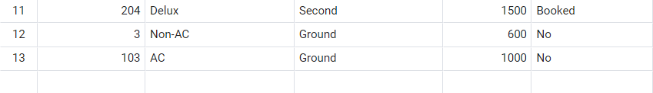

**Room Information:**

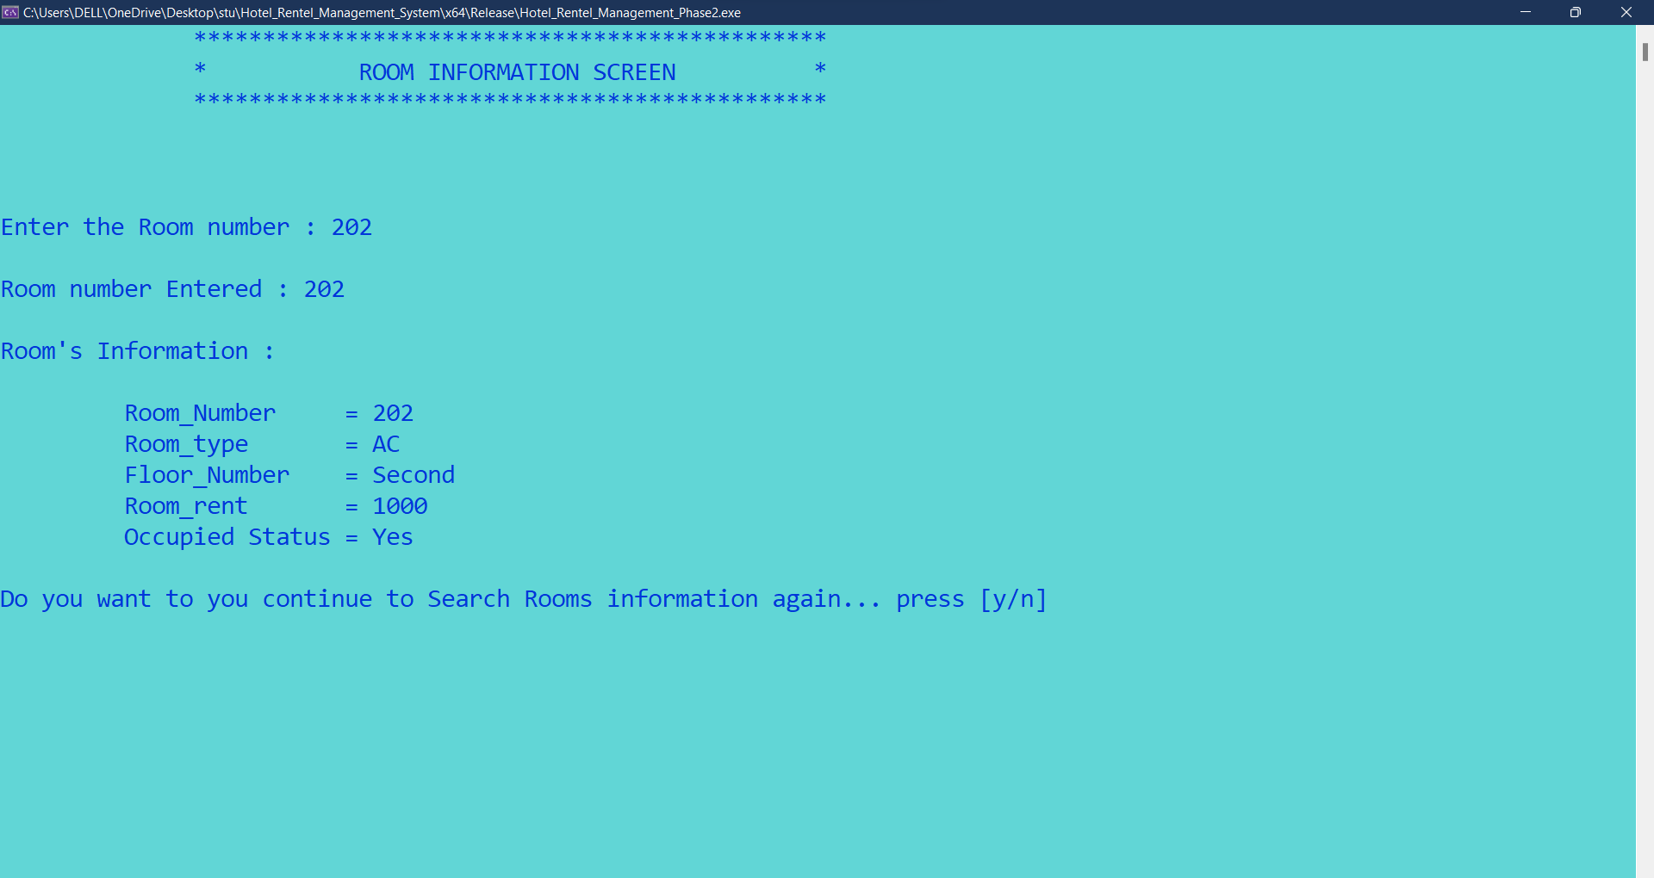

The above screen describes the search room information ( hotel_room_info table ) according to the room number to check whether the room is vacant or occupied .

**Receptionist Main Menu Screen:**

On Pressing 2 .🡪MANAGE GUESTS IN HOTEL:

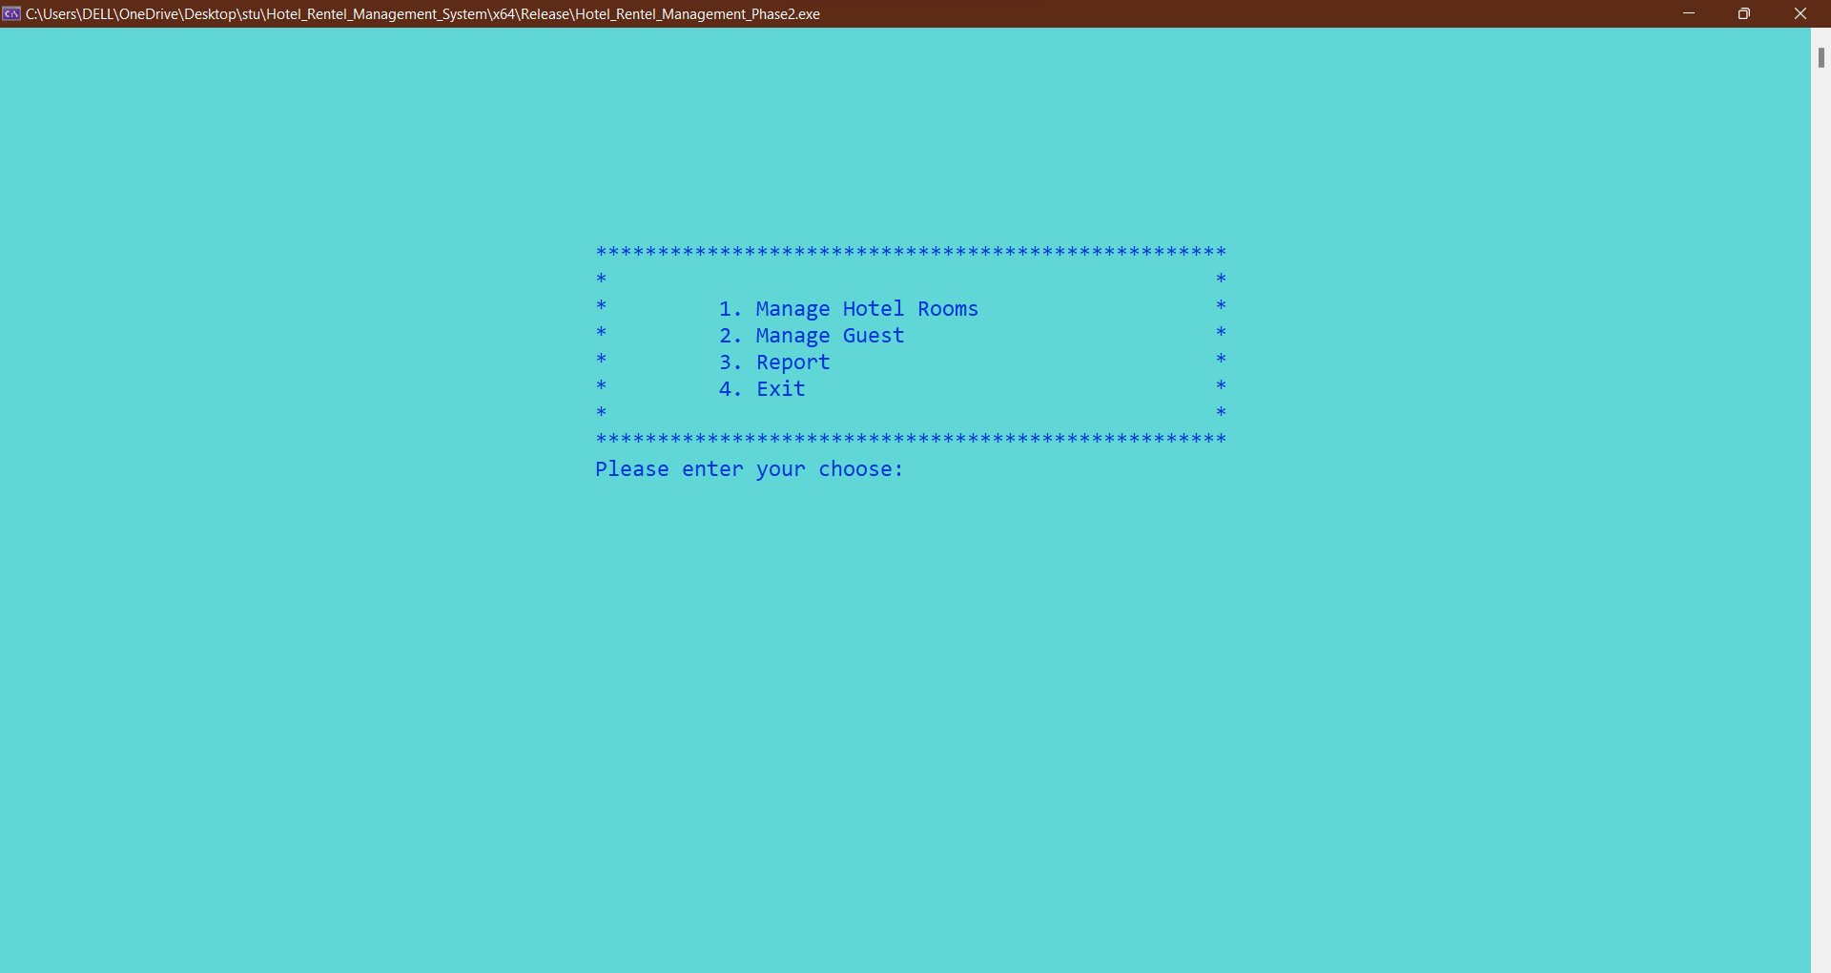

**Manage Guest Main Screen:**

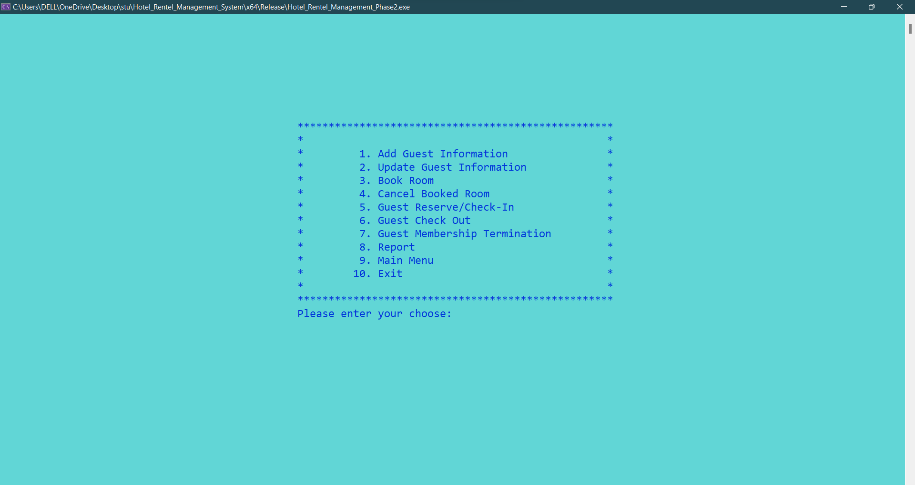

**On Pressing 1.** 🡪 **ADD Guest Information:**

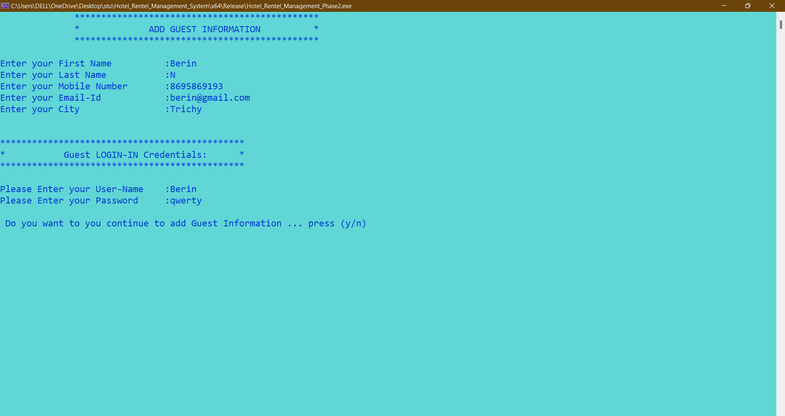

**Hotel Rooms Information in table after inserting:**

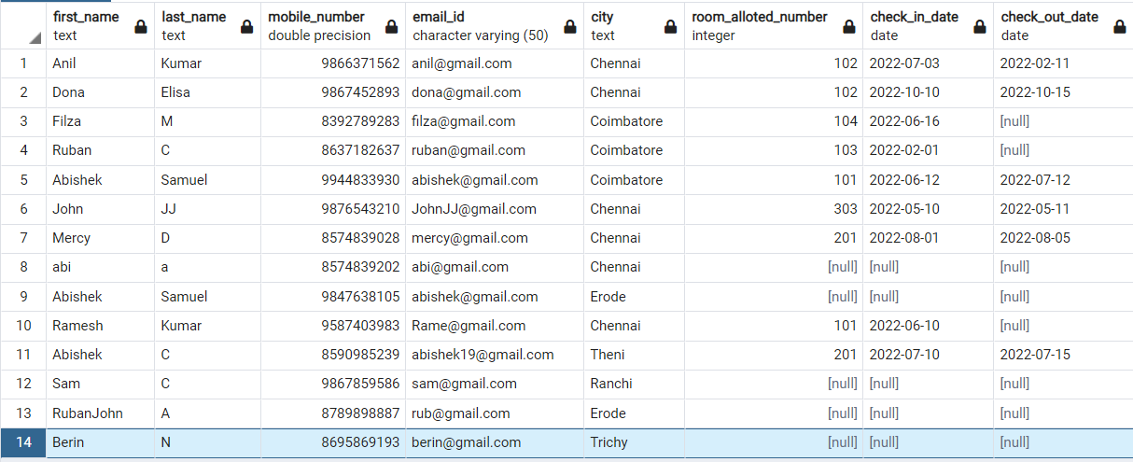

In the Table [null] is given because the guest might booked a room or Guest didn’t sart booking or reserving Rooms.

**On Pressing 2.** 🡪 **UPDATE Guest Information:**

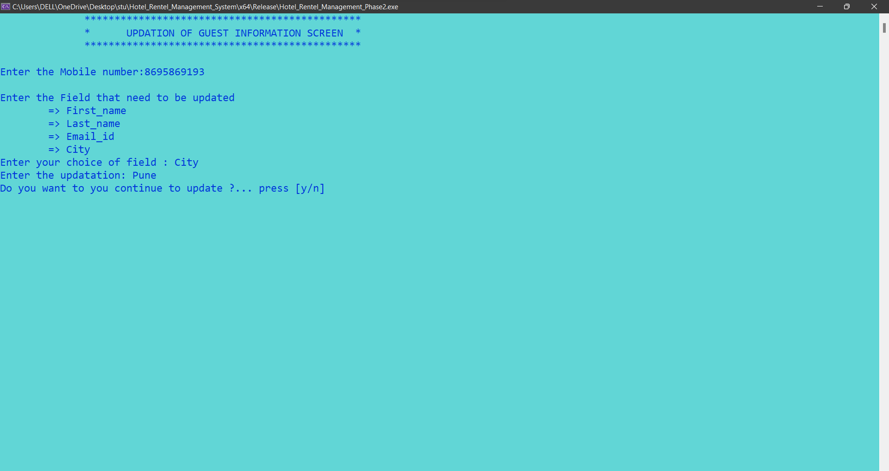

**Hotel Rooms Information in table after Updating:**



**On Pressing 3.** 🡪**To Book a Room:**

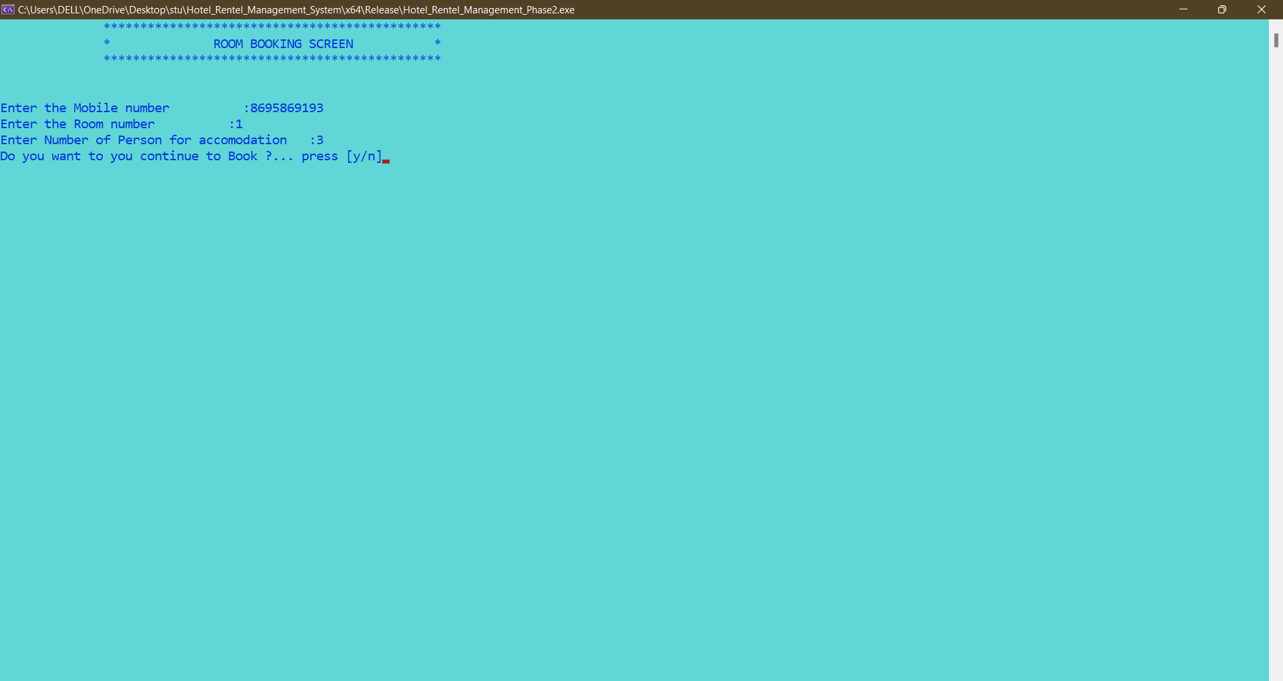

**Bookin_info Table:**

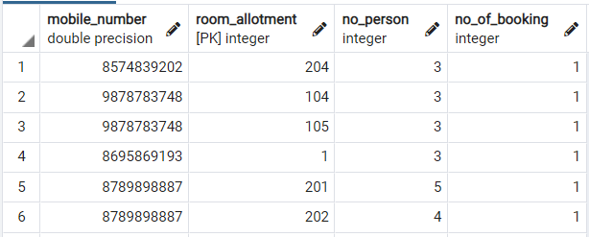

**In Hotel Room Info table:**

The occupied Status Changed into **“Booked”**



If the room is already reserved there will be popup that **“The Room has been Reserved”**

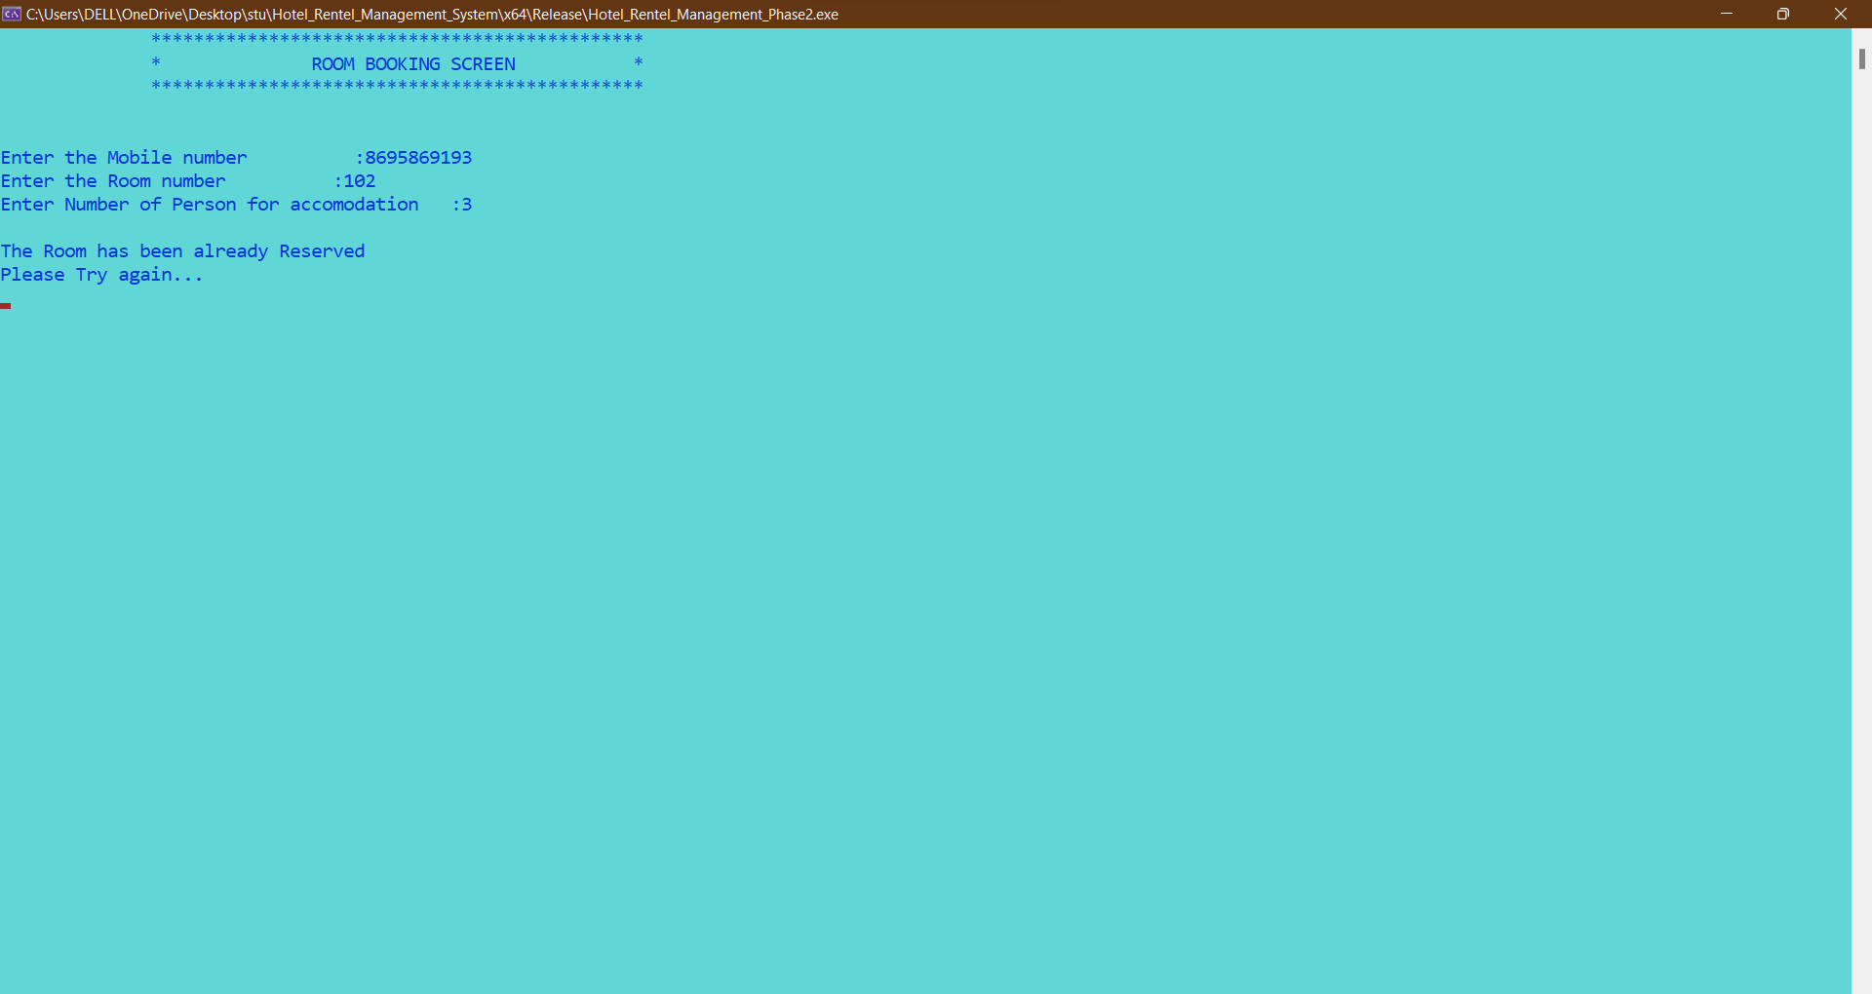

**On Pressing 4.** 🡪**To Cancel a Booked Room:**

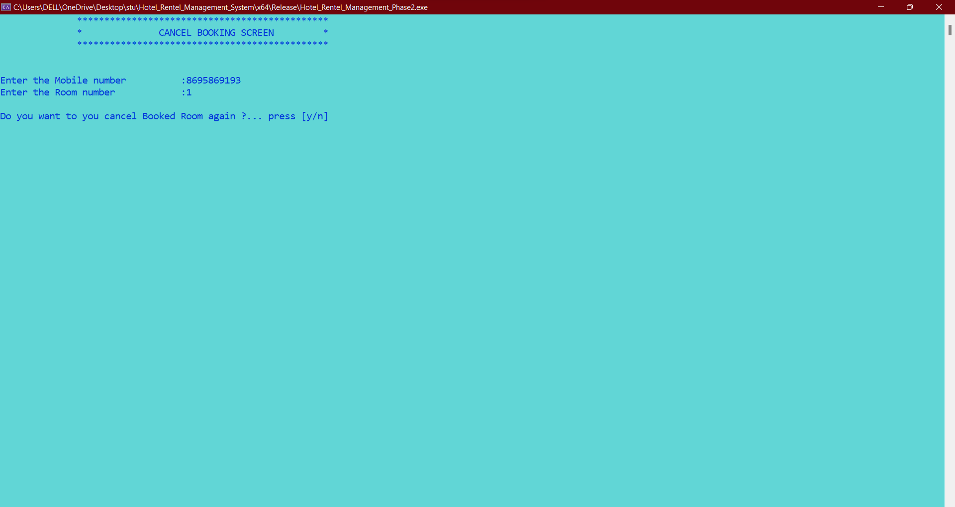

**In Hotel Room Info table:**

After Cancellation the occupied Status Changes into **“No”**



**On Pressing 5.** 🡪**To Reserve a Room:**

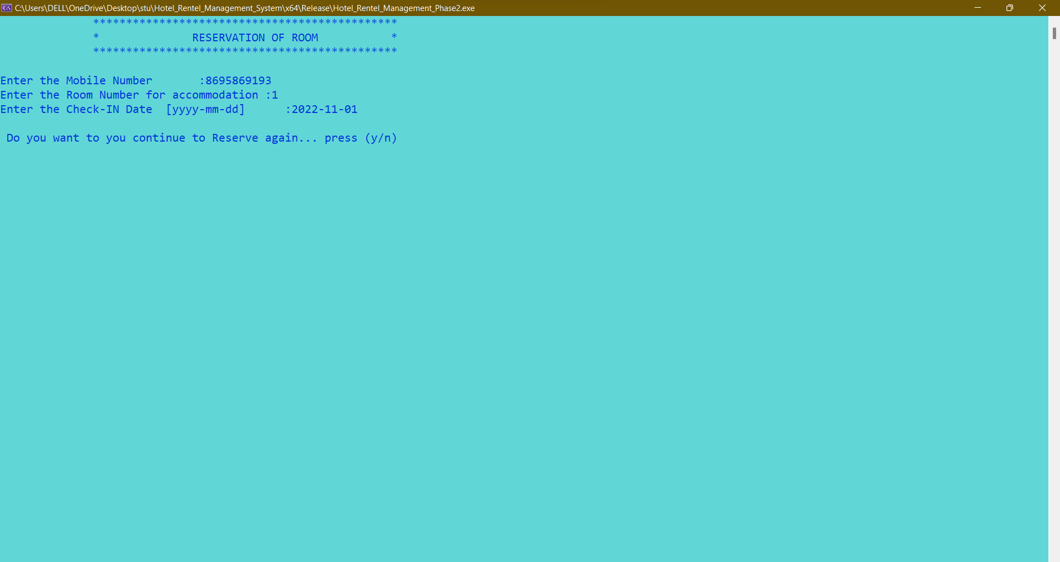

**Guest_info Table:**



**In Hotel Room Info table:**

After Reserving the room, the occupied Status Changes into **“Yes”**



**On Pressing 6.** 🡪**To Check-Out from a Reserved Room:**

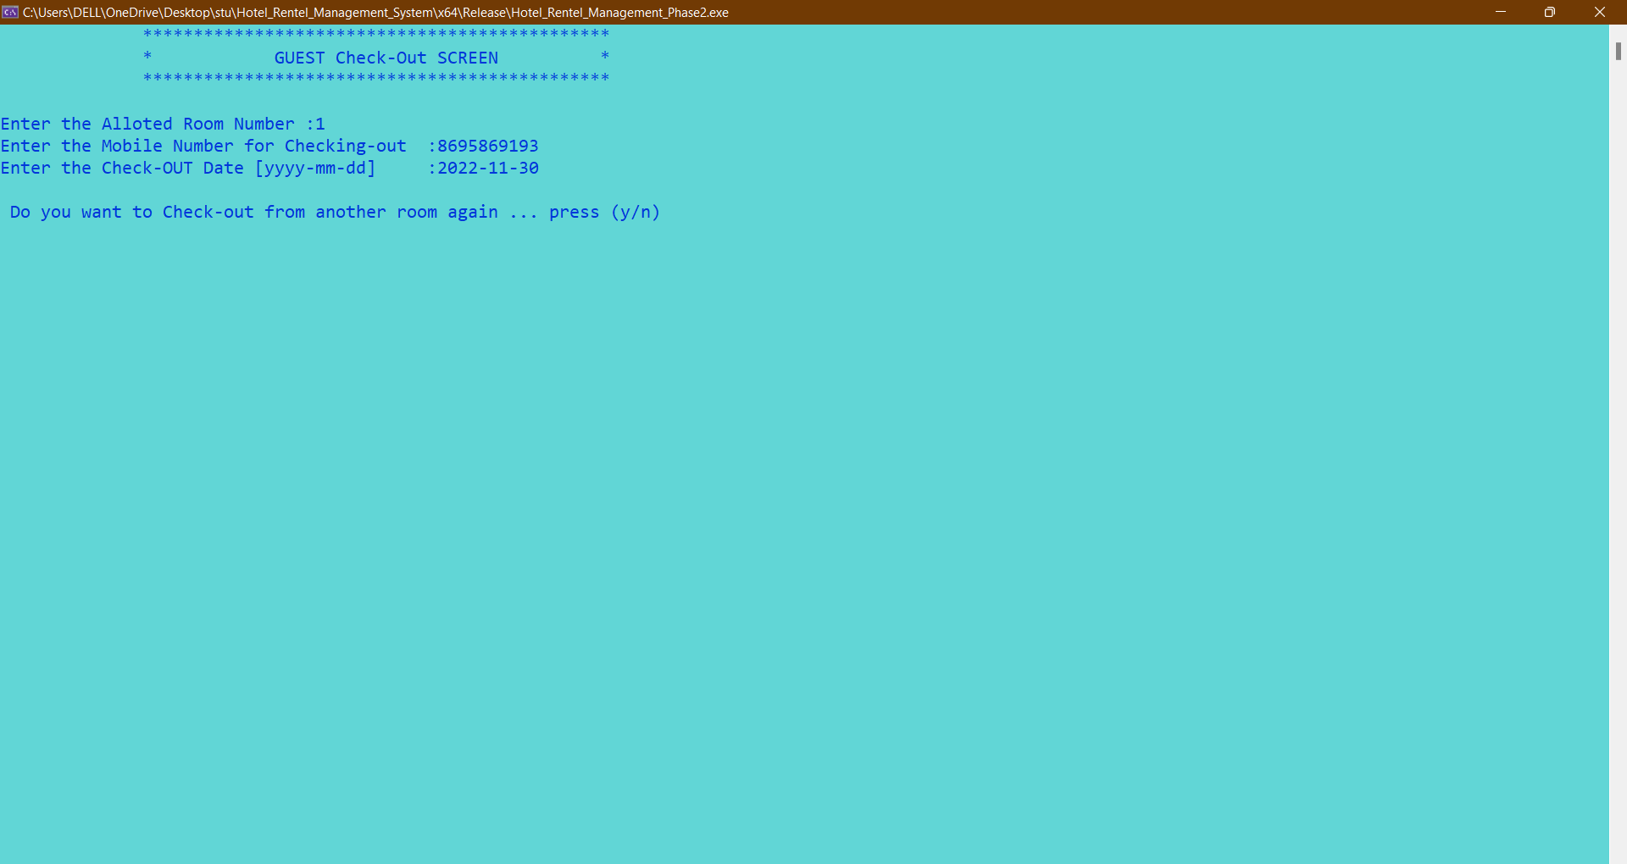

**Guest_info Table:**



**In Hotel Room Info table:**

After Checking-Out the room, the occupied Status Changes into **“No”**



**On Pressing 7.** 🡪**Termination of Guest Membership:**

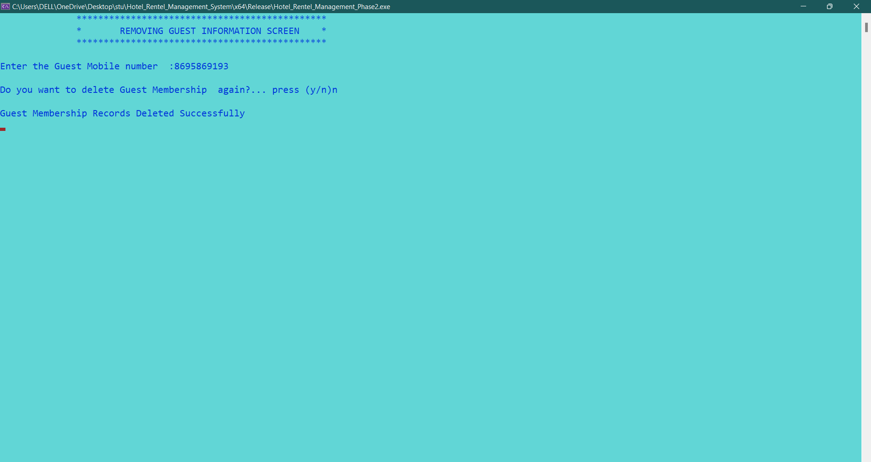

**On Pressing 8.** 🡪**Report:**

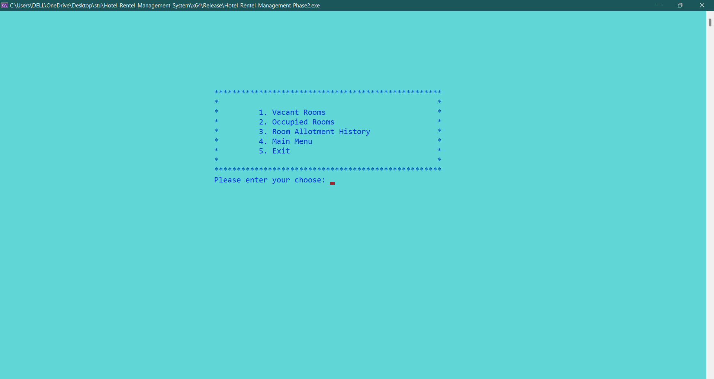

**On Pressing 1 => Vacant Rooms Available (Report)**

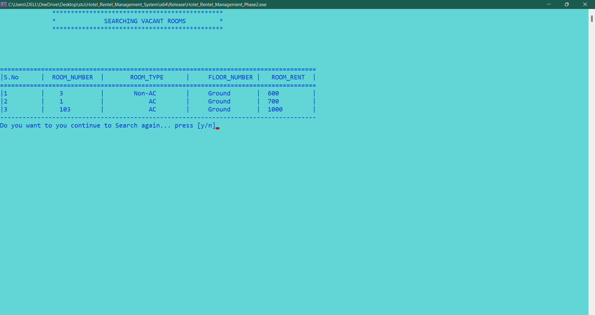

**On Pressing 2 => Occupied Rooms (Report)**

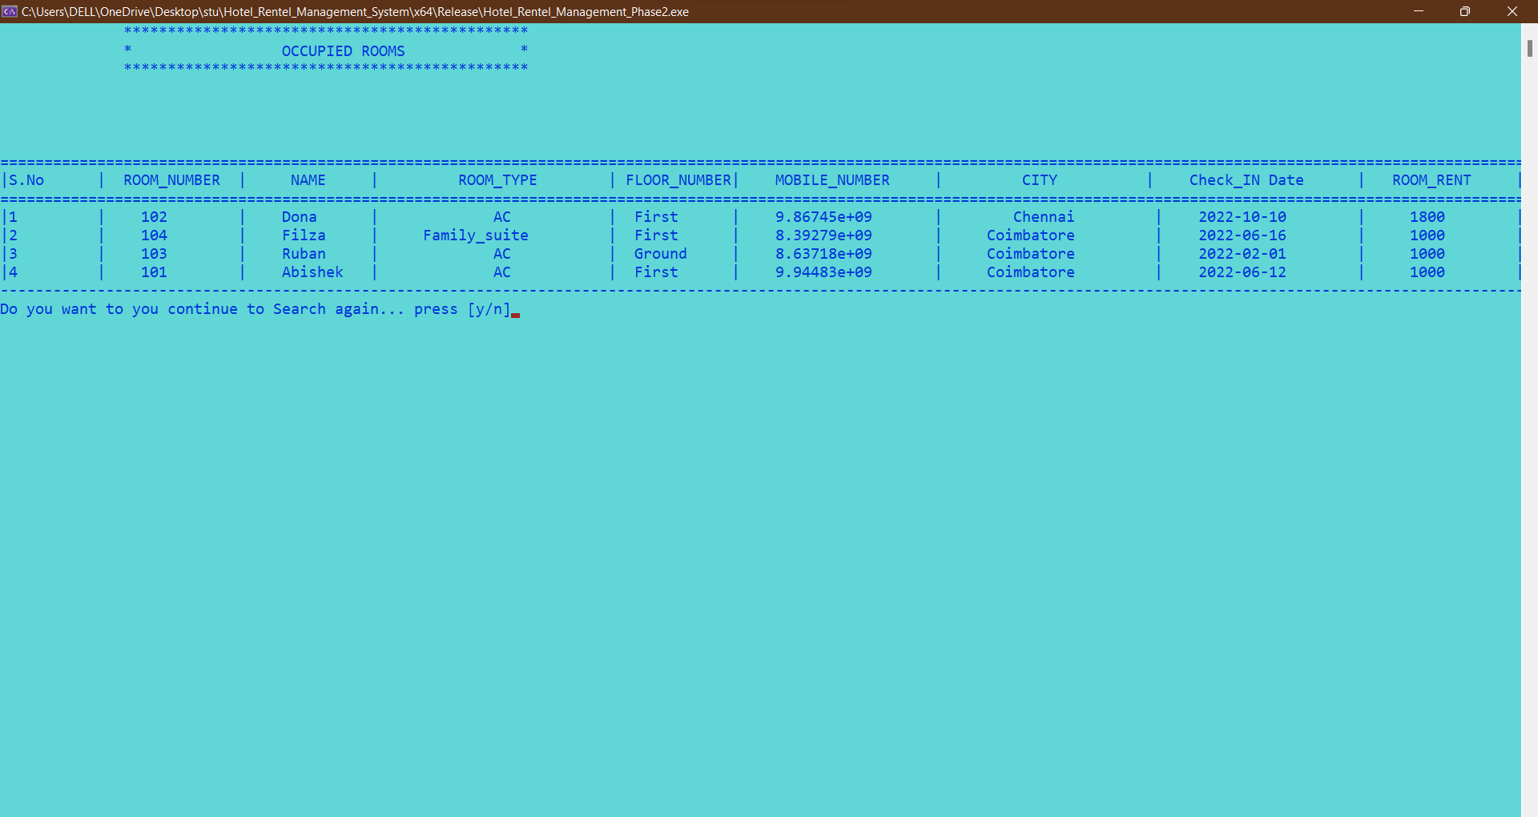

**On Pressing 3 => Room Allotment History (Report)**

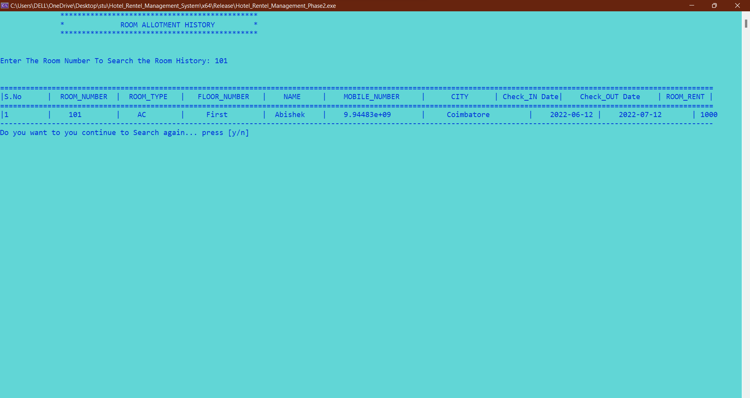

**Exit Screen for Receptionist:**

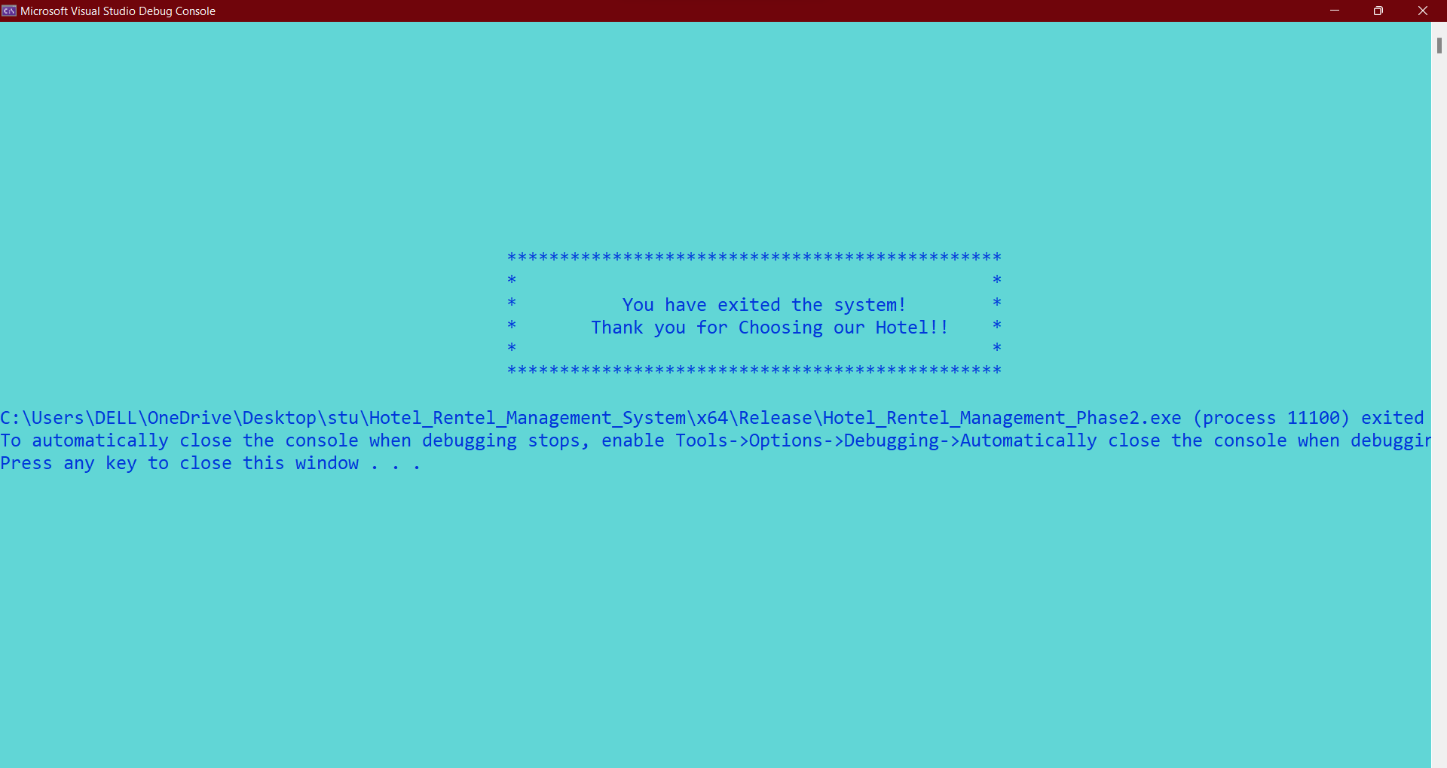

**GUEST LOGIN MENU**

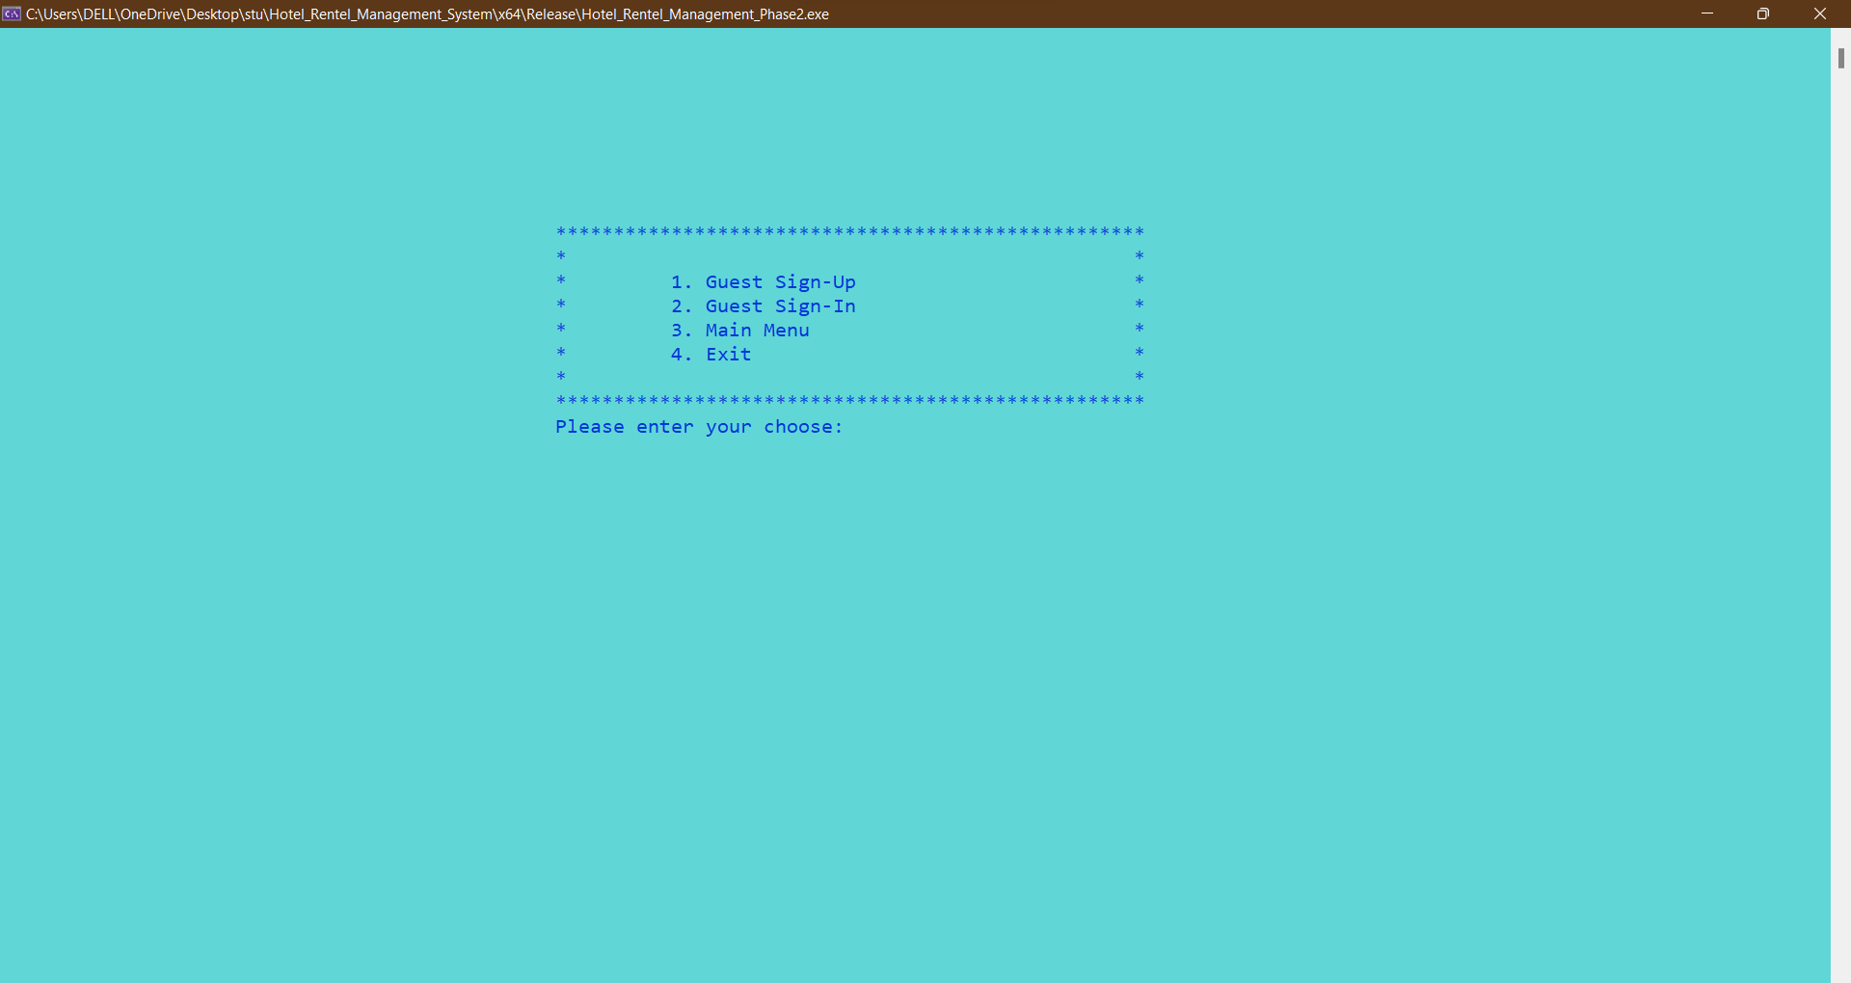

1.Guest Sign-Up Screen:

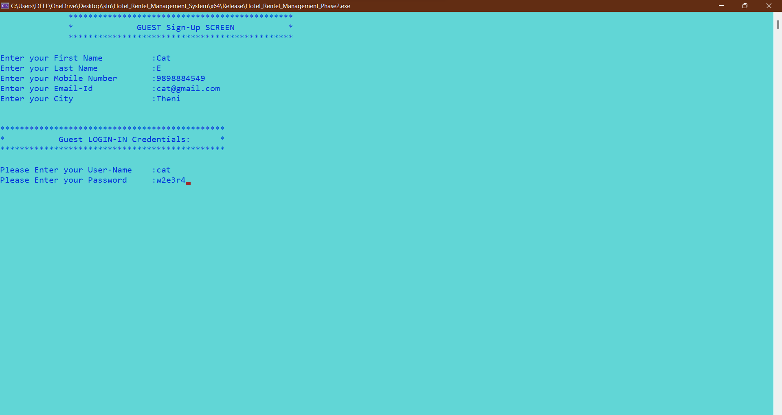

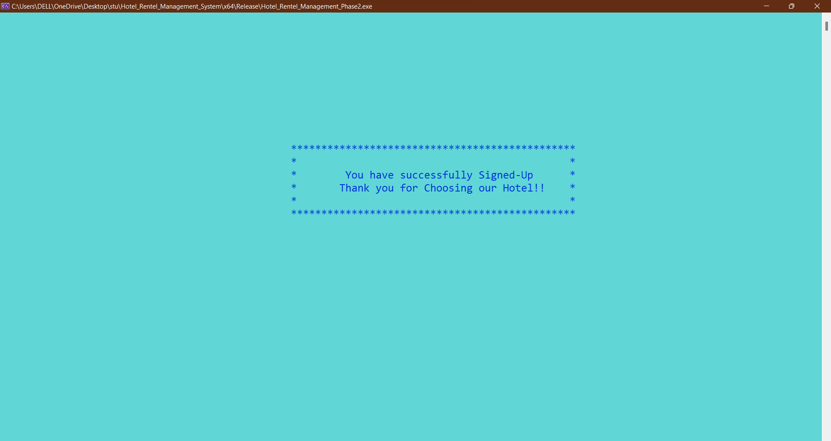

2.Guest Sign-In Screen:

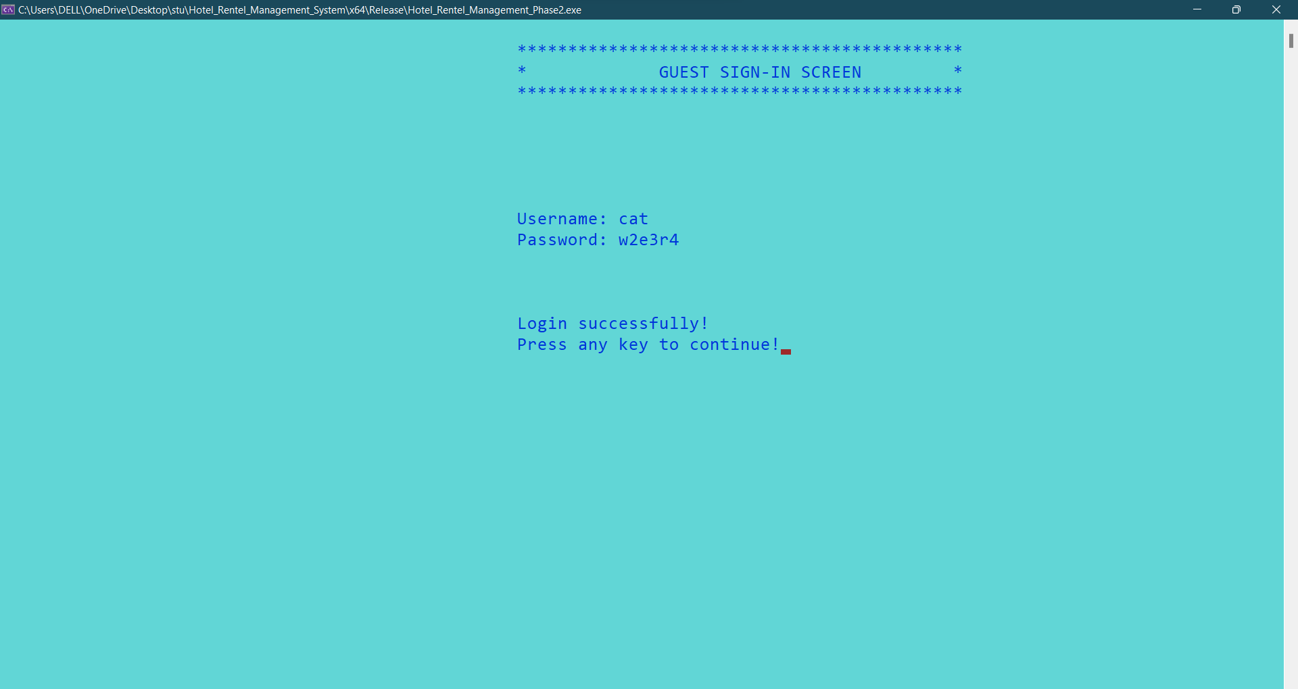

**Guest Login-Credentials Table:**

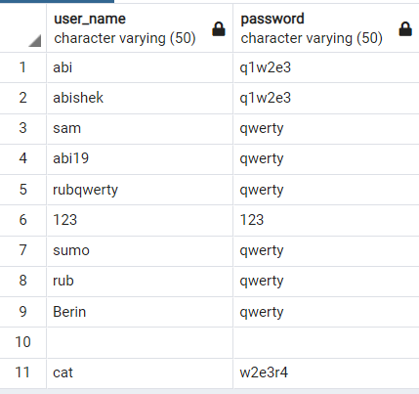

**Guest Console:**

After Sign-In ->

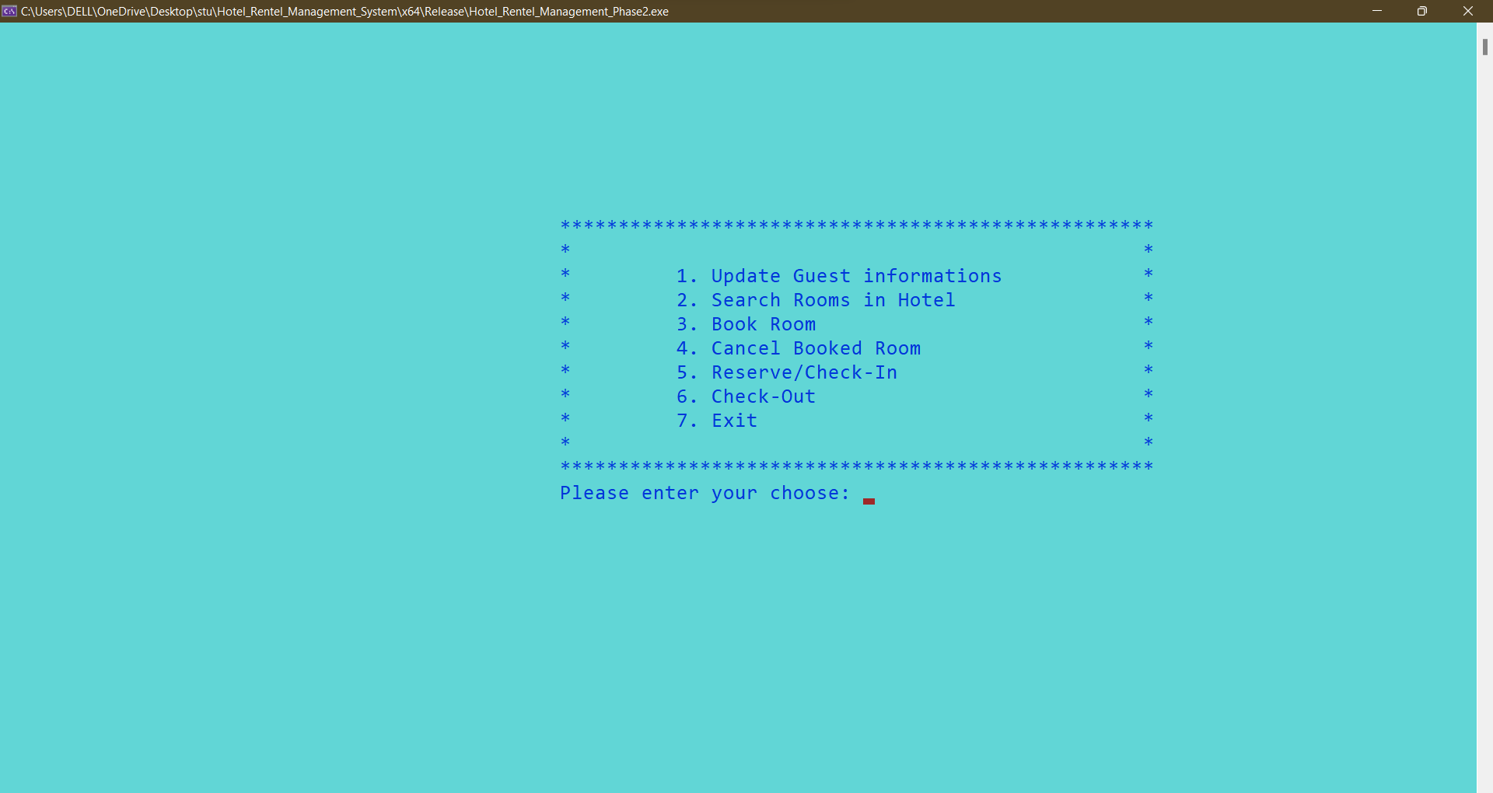

**On Pressing 1.** 🡪 **UPDATE Guest Information:**

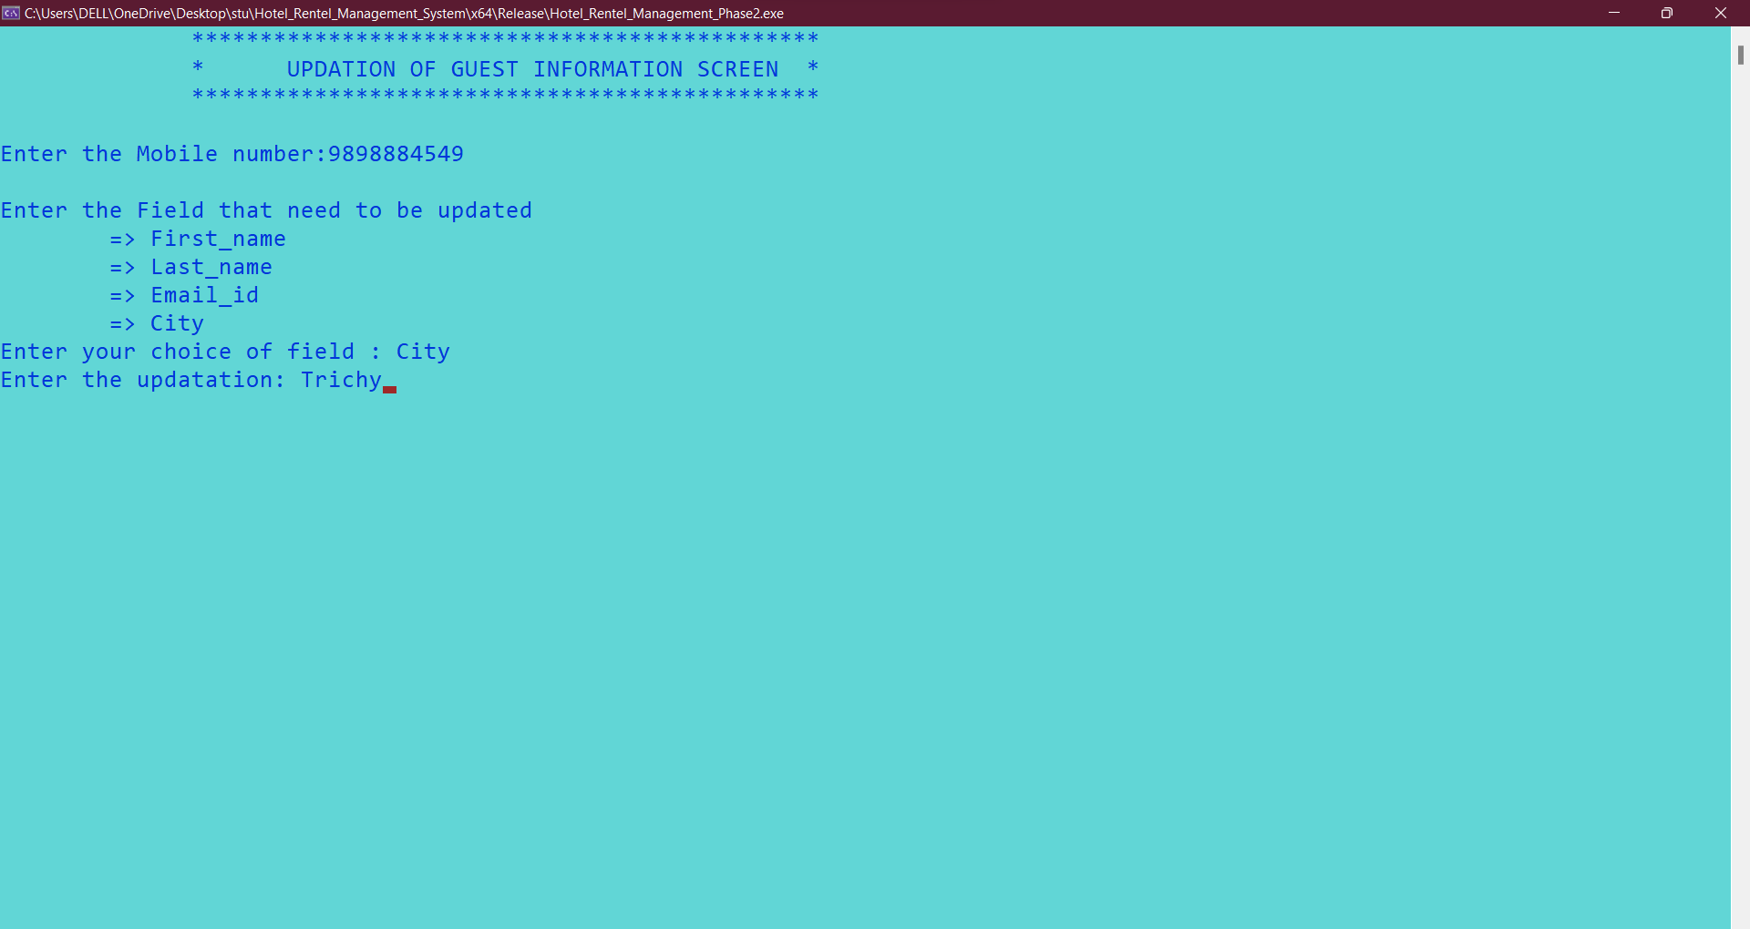

**Guest Information in table after Updating:**





**On Pressing 2.** 🡪 **Search Rooms:**

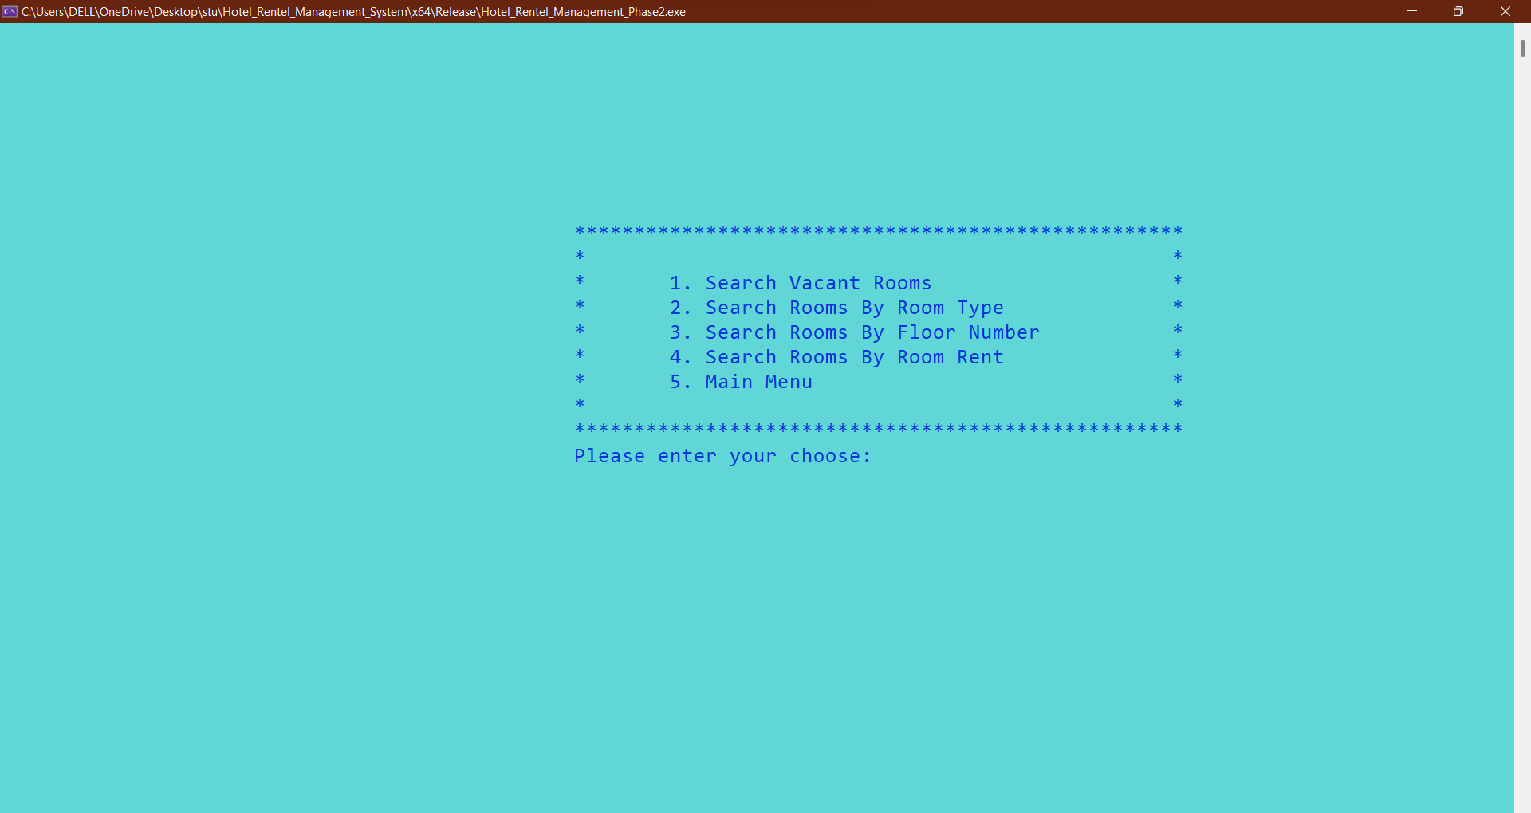

**On Pressing 1.** 🡪 **Vacant Rooms:**

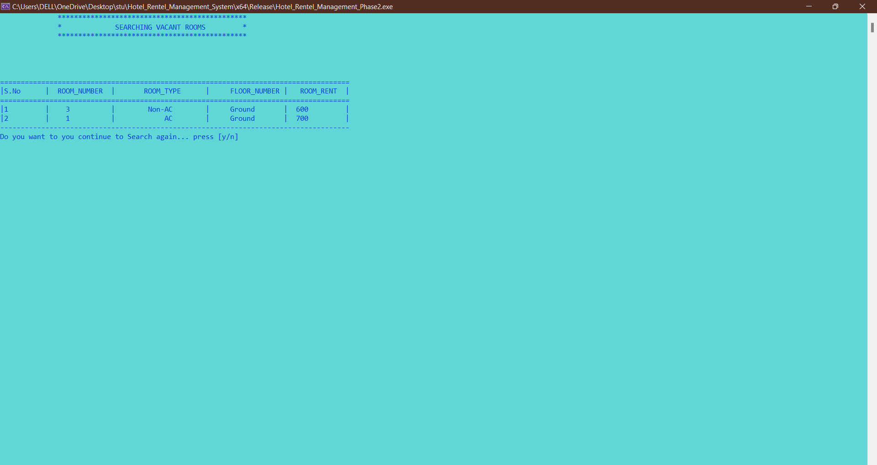

**On Pressing 2.** 🡪 **Search Rooms According to ROOM TYPE:**

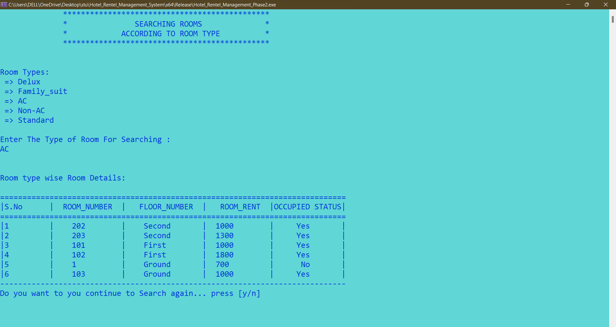

**ROOM TYPE Search in Hotel_room_info Table:**

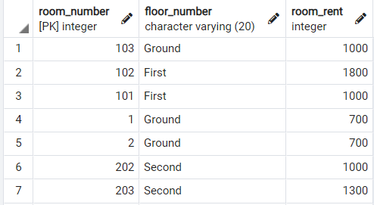

**On Pressing 3.** 🡪 **Search Rooms According to FLOOR NUMBER:**

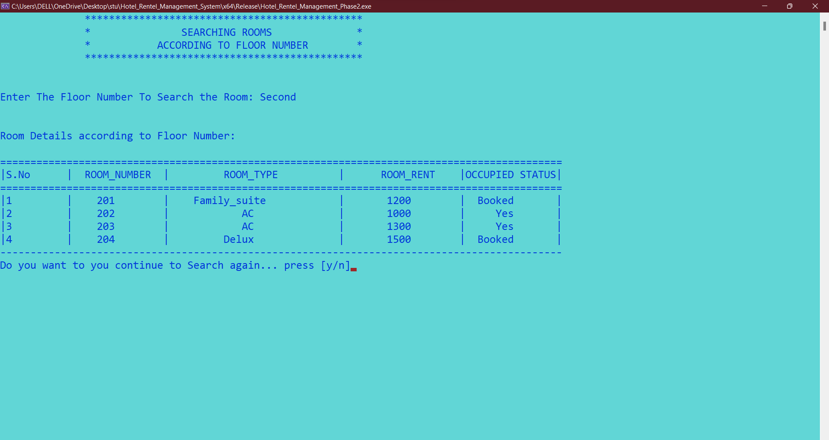

**FLOOR NUMBER Search in Hotel_room_info Table:**

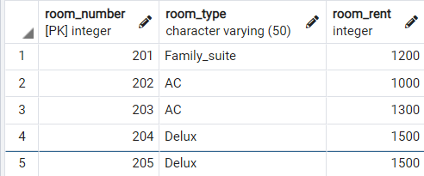

**On Pressing 4.** 🡪 **Search Rooms According to Room Price Range**

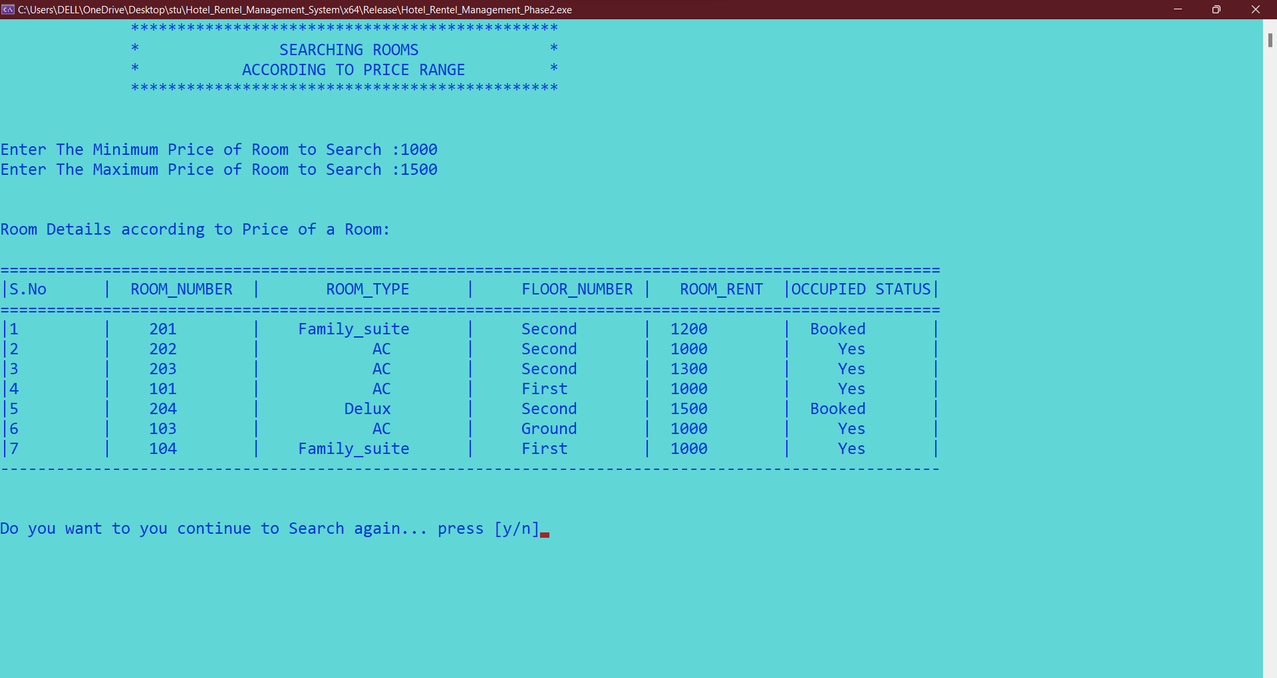

**Room Rent Price-Range Search in Hotel_room_info Table:**

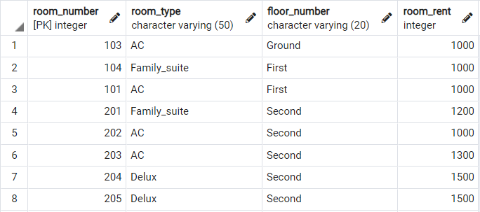

**On Pressing 3.** 🡪  **Book Rooms Screen:**

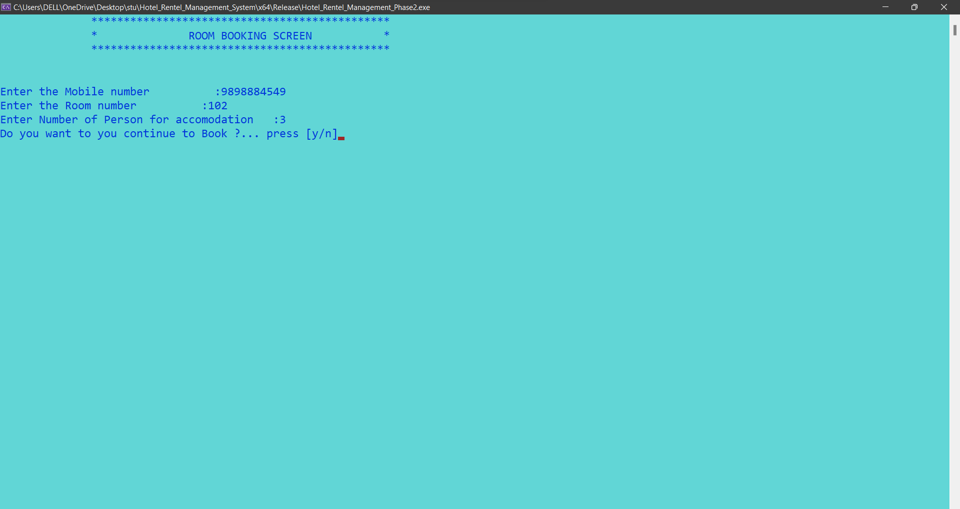

**In Booking-Info Table:**

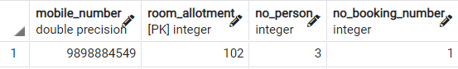

**In Hotel_Room_info Table:**

After Booking the room, the occupied Status Changes into **“Booked”**



If the room is already reserved there will be popup that **“The Room has been Reserved”**



**On Pressing 4.** 🡪 **Cancel** **Booked Rooms Screen:**

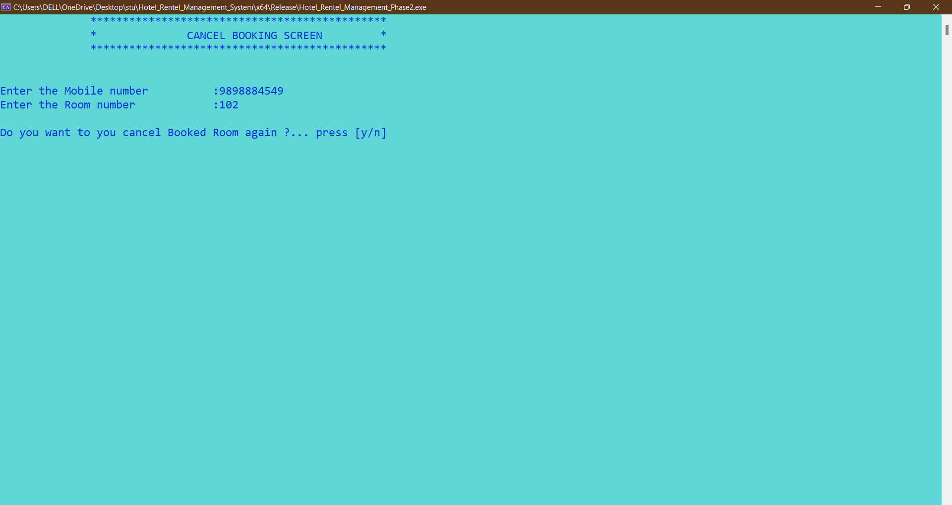

**In Hotel_Room_info Table:**

After Cancelling the booked room, the occupied Status Changes into **“No”**



**On Pressing 5.** 🡪 **Reserve a** **Rooms Screen:**

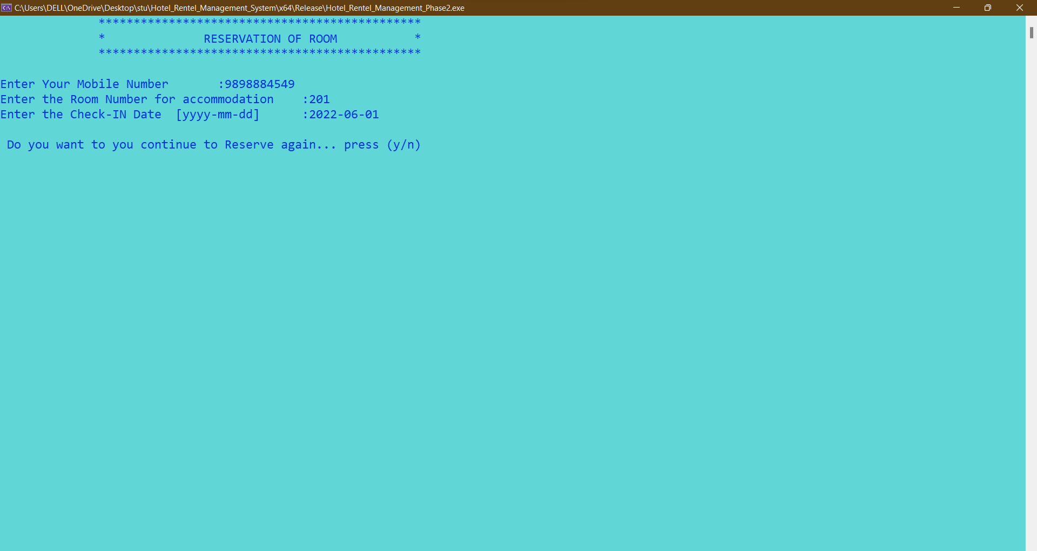

**Guest_info Table:**



**In Hotel Room Info table:**

After Reserving the room, the occupied Status Changes into **“Yes”**



**On Pressing 6.** 🡪**To Check-Out from a Reserved Room:**

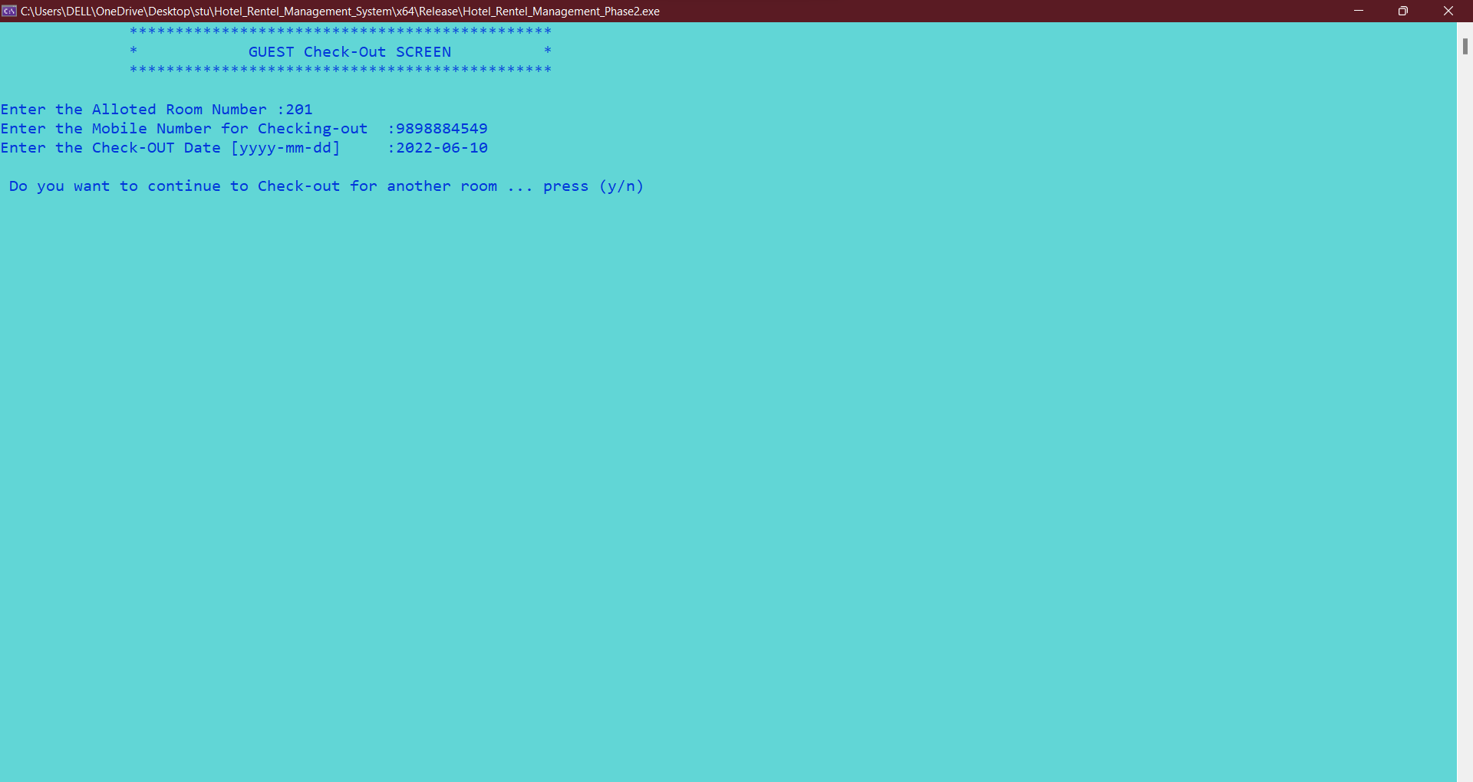

**Guest_info Table:**



**In Hotel Room Info table:**

After Checking-Out the room, the occupied Status Changes into **“No”.**



**Guest EXIT SCREEN:**

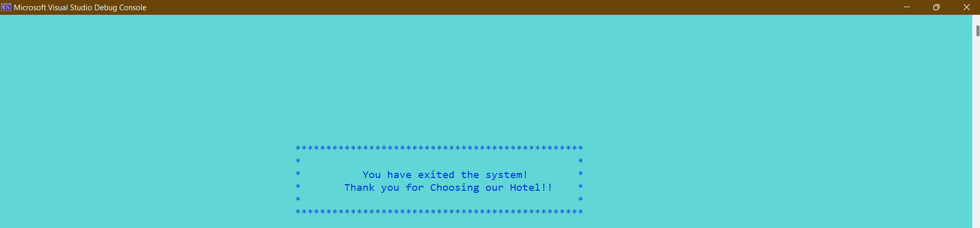

Thanking you

Abishek Samuel